Applecross Senior High School
Semester 1 Examination, 2010

Question/Answer Booklet

HUMAN
BIOLOGICAL
SCIENCE
Stage 3

Student Name
Teacher

Time allowed for this paper
Reading time before commencing work: ten minutes
Working time for paper: three hours

Materials required/recommended for this paper

To be provided by the supervisor
This Question/Answer Booklet
Multiple-choice Answer Sheet

To be provided by the candidate
Standard items: pens, pencils, eraser, correction fluid, ruler, highlighters
Special items: non-programmable calculators satisfying the conditions set by the Curriculum Council for this course

Important note to candidates
No other items may be taken into the examination room. It is your responsibility to ensure that you do not have any unauthorised notes or other items of a non-personal nature in the examination room. If you have any unauthorised material with you, hand it to the supervisor before reading any further.
Structure of this paper

Section | Number of questions available | Number of questions to be answered | Suggested working time  (minutes) | Marks available | Percentage of exam
Section One:  Multiple-choice | 20 | 20 | 30 | 20 | 20
Section Two:  Short answer | 9 | 9 | 90 | 100 | 50
Section Three:  Extended answer | 3 | 2 | 60 | 60 | 30
 |  |  |  |  | 100

Instructions to candidates

1. The rules for the conduct of Western Australian external examinations are detailed in the Year 12 Information Handbook 2010. Sitting this examination implies that you agree to abide by these rules.

2. Answer the questions according to the following instructions.

Section One: Answer all questions on the separate Multiple-choice Answer Sheet provided. For each question shade the box to indicate your answer. Use only a blue or black pen to shade the boxes. If you make a mistake, place a cross through that square, do not erase or use correction fluid, and shade your new answer. Marks will not be deducted for incorrect answers. No marks will be given if more than one answer is completed for any question.

Sections Two and Three: Write answers in this Question/Answer Booklet.

3. You must be careful to confine your responses to the specific questions asked and to follow any instructions that are specific to a particular question.

4. Spare pages are included at the end of this booklet. They can be used for planning your responses and/or as additional space if required to continue an answer.
  - Planning: If you use the spare pages for planning, indicate this clearly at the top of the page.
  - Continuing an answer: If you need to use the space to continue an answer, indicate in the original answer space where the answer is continued, i.e. give the page number. Fill in the number of the question(s) that you are continuing to answer at the top of the page.

Section One: Multiple-choice 20% (20 Marks)

This section has 20 questions. Answer all questions on the separate Multiple-choice Answer Sheet provided. For each question shade the box to indicate your answer. Use only a blue or black pen to shade the boxes. If you make a mistake, place a cross through that square, do not erase or use correction fluid, and shade your new answer. Marks will not be deducted for incorrect answers. No marks will be given if more than one answer is completed for any question.

Suggested working time for this section is 30 minutes.
________________________________________________________________________

1. Populations that are _________ are likely to undergo rapid evolution.
A) small and isolated
B) small but only partially isolated from the parent population
C) large and under diverse selective pressures
D) large and isolated from other similar species

2. Which of the following plays a role in speciation?
A) lack of phenotypic variants in a population
B) natural selection
C) geographic isolation of organisms that were once in the same population
D) Both B and C

3. In the year 2317, a group of 507 pioneers colonize Mars. The incredible distance between Mars and Earth excludes the possibility of new members joining the colony. This situation is an example of
A) genetic drift.
B) mutation.
C) the founder effect.
D) artificial selection.

4. Which of the following is least to be related to arboreal life among primates?
A) stereoscopic vision
B) reduced sense of smell
C) a clavicle
D) bipedalism

5. Which of the following is not unique to humans among living primates?
A) relative lack of body hair
B) a dish-shaped pelvis
C) opposable thumbs
D) a parabolic jaw

6. Which of the following would be considered a fossil?
A) a stone arrow head
B) an impression left by a plant on sediment that later turned to stone
C) a piece of mineralised skull
D) B and C

7. An environmental change that may have influenced the evolution of the first hominins was:
A) a trend toward greater rainfall and humidity, with an expansion of the rainforests.
B) a gradual warming of the environment
C) a drying trend, leading to the reduction of forests and the expansion of grasslands
D) the beginning of a glacial period, with falling sea levels and lessening rainfall.

8. The ease with which humans travel across the globe is likely to increase _____.
A) natural selection
B) gene flow
C) mutation
D) genetic drift

9. Imagine you are looking at a DNA fingerprint that shows a pattern of a mother's DNA and her child's DNA. Will all of the bands showing the child's DNA match those of the mother?
A) No, because a person’s DNA pattern changes with age.
B) Yes, because the DNA of mothers and children are identical.
C) Yes, because the child developed from an egg produced by the mother.
D) No, because the father contributed half of the child's DNA.

10. The bases on one strand of DNA are CTAGAAC. The complementary section on the other strand of DNA is
A) CTAGAAC
B) AGCTCCA
C) GATCTTG
D) GUTCTTG

11. Rejoining DNA fragments from two organisms is best known as
A) conjugating DNA
B) declining DNA
C) mapping genes
D) recombinant DNA technology

12. According to the fluid mosaic model of the plasma membrane, proteins are
A) spread out in a continuous layer over both membrane surfaces
B) located in the hydrophilic area of the membrane
C) oriented in a random manner throughout the membrane
D) embedded in the lipid bilayers

Use the diagram below to assist you in answering questions 13 to 14.

13. Structure A contains a
A) gene
B) messenger RNA molecule
C) single nucleotide, only
D) small polysaccharide

14. Structure B represents
A) a ribosome
B) recombinant DNA
C) transfer RNA
D) a female gamete

15. Which of the following statements regarding epigenetic inheritance is TRUE?
A) Epigenetic inheritance involves a change in mitochondrial DNA.
B) Epigenetic inheritance permanently affects an individual.
C) Epigenetic inheritance does not involve a change in DNA sequence.
D) Epigenetic inheritance is a temporary change in DNA.

16. Which of the following is an example of polymorphism in humans?
A) variation in emotions
B) variation in fingerprints
C) the presence or absence of a widow’s peak
D) variation in height

17. What is the key to the recognition of codominance?
A) The heterozygote expresses the phenotype of both homozygotes.
B) The alleles affect more than one trait.
C) The dominant alleles is not always expressed.
D) The phenotype of the heterozygote falls between the phenotypes of the homozygotes.

18. A new organism is discovered in the outback of Western Australia. Scientists have determined that the polypeptide sequence of haemoglobin from the new organism has 68 amino acid difference from humans, 62 differences from a gibbons, 24 difference from a rat, and 6 difference from a frog.
These data:
A) show that the new organism is best adapted to an aquatic environment.
B) indicate the new organism may be closely related to frogs.
C) suggest that the new organism is closely related to humans.
D) suggest that the new organisms evolved from gibbons but not rats and mice.

19. Which of these is an example of an adult stem cell?
A) A red blood cell.
B) A neuron.
C) A cell from an embryo.
D) Skin cells that produce new epithelial layers.

20. Which of the following features is NOT an important evolutionary advancement in the evolution of the arboreal primates?
A) opposable thumbs.
B) stereoscopic vision.
C) elongated snout with well-developed sense of smell.
D) the ability to see in colour.

End of Section One

This page has been left blank intentionally
Section Two: Short answer 50% (100 Marks)

This section has ten questions. Answer all questions. Write your answers in the space provided.

Spare pages are included at the end of this booklet. They can be used for planning your responses and/or as additional space if required to continue an answer.
  - Planning: If you use the spare pages for planning, indicate this clearly at the top of the page.
  - Continuing an answer: If you need to use the space to continue an answer, indicate in the original answer space where the answer is continued, i.e. give the page number. Fill in the number of the question(s) that you are continuing to answer at the top of the page.

Suggested working time for this section is 90 minutes.

Question 21 (10 marks)

a. The diagram is of three lower jaw outlines.

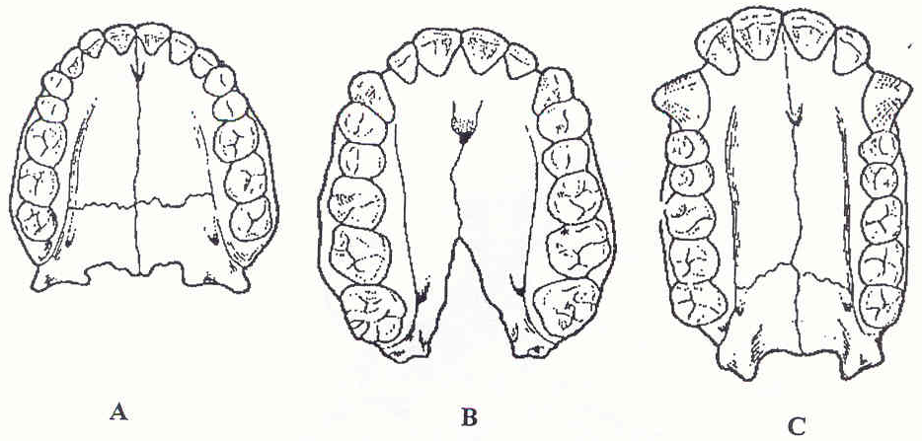

(i) Which of the three jaws is that of an ape - A, B or C?

C
1 mark

(ii) Give TWO reasons for your answer.

Apes have a diastema, large carnines, rectangular jaw, large premolars

2 marks

In October 2004, on the remote Indonesian island of Flores, archaeologists discovered bones from a new species of human called Homo floresiensis. These humans were much smaller than modern humans, with adults being about 1 metre in height and weighing around 25 kilograms. Bones from six or seven individuals have been discovered in sediments ranging in age from 94 000 to 13 000 years. The skeletons indicate that these humans had relatively long arms and a very small brain relative to body size, about equivalent to that of a chimpanzee. They had hard, thick eyebrow ridges and a sharply sloping forehead and no chin. Modern humans, Homo sapiens, are thought to have evolved somewhere between 55 000 and 35 000 years ago.

b. It has been suggested that Homo floresiensis evolved from a population of Homo erectus. List any two features from the fossil remains that support this view.

* thick eyebrow ridges
• sloping forehead
• no chin.
- smaller cranial capacity in relation to body size (if you stretched Homo floresiensis to the same height as Homo erectus brain may be similar in size)

do not accept: height, small cranial capacity, longer arms

2 marks
c. Suggest and explain a method by which the ages of the bones of Homo floresiensis were estimated if found in sediments 13 000 years old.

carbon 14 dating
compare amount of C14 to C12
Determine what percentage of C14 remains
Use a decay curve graph to determine the number of half-lives
Multiply number of half lives by 5730

5 marks

Question 22 (12 marks)

The following diagram outlines events associated with the production of a polypeptide chain in a eukaryotic
cell.

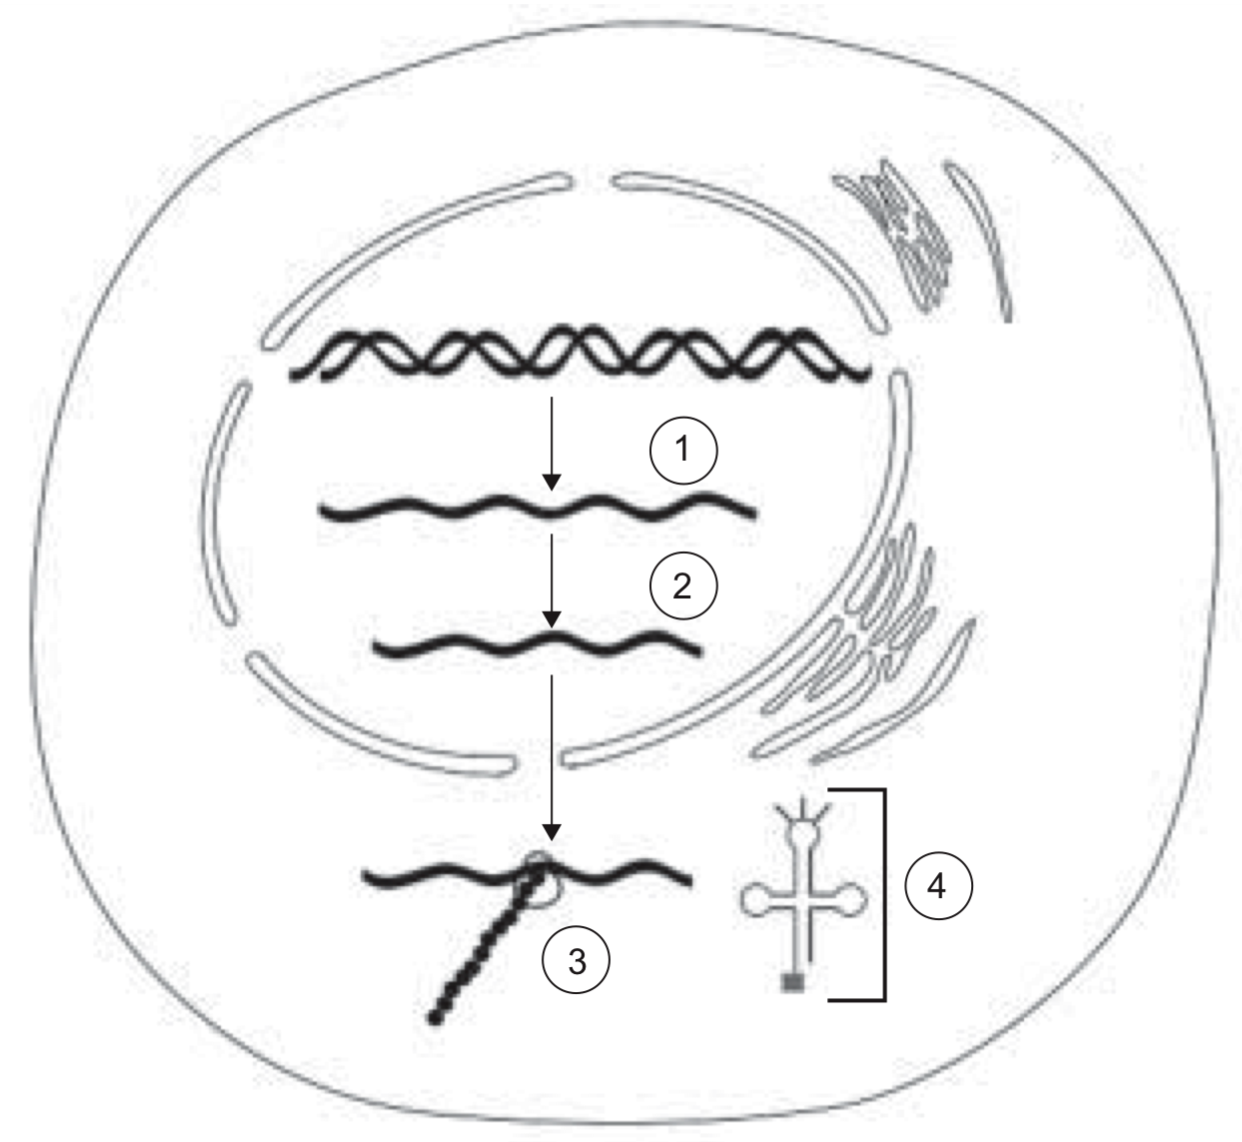
VCE 2006 Written Exam 2 page 12

- What is the name of the process at step 1?

transcription
1 mark

- i. Name the product of step 1.

mRNA
1 mark

ii. Why is the strand in step 2 shorter than the strand in step 1.

Introns have been removed
1 mark

c. Name the event that occurs at structure 3.

translation
1 mark
d. i. Name the structure at 4.

transfer RNA
1 mark

ii. Outline the function of the structure you named in the question above. (Question 22 d.i.)

Transfer RNA brings a specific amino acid to the ribosome.
The anticodons of the tRNA are complementary to the codons of the mRNA.
tRNA brings amino acids to the ribosome – bind with appropriate codon of mRNA

2 marks

Below is the DNA sequence from the beginning of a gene coding for an enzyme involved in metabolism. The upper line of bases (in bold) represents the template strand.

TACTTTAAGAGCTTATCG ←template strand
ATGAAATTCTCGAATAGC

_________________________________

e. Write the mRNA sequence that would be transcribed from this DNA sequence.

______A U G A A A U U C U C G A A U A G C _____________________________
1 mark

Use the table of part of the genetic code (below) to answer parts f and g.

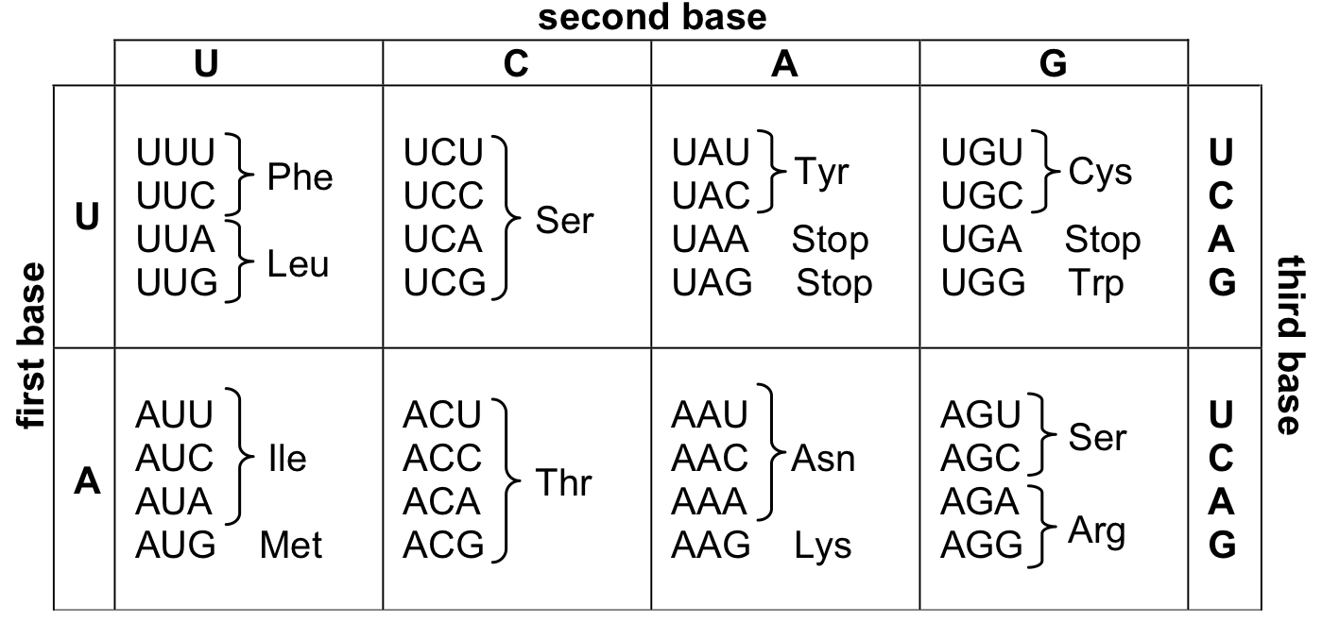

f The 6th base on the template strand of the sequence above is substituted by C. Explain the effect this mutation will have on the amino acid sequence of the protein produced.

There will be a different amino acid in the amino acid sequence. (1) Asn (asparagine) is replaced by Lys (lysine) (1)
2 marks

g. The 11th base pair of the sequence is deleted. Explain the effect that this mutation will have on the amino acid sequence of the protein produced.

The amino acid sequence will be shortened (1) as a stop codon has been introduced (1) into the mRNA.

2 marks

Question 23 (13 marks)

a) Briefly explain the main ideas in Darwin’s theory of evolution.

* parents produce more offspring than survive
* there is competition among members of a species for survival/struggle for existence
* species show variation
* certain variations will give a selective advantage/survival of fittest
* depending on environment
* these variations will be passed on to the next generation
(any 4)

do not accept references to genetics –
do not accept reference to” “survival of the fittest”, “struggle for existence” without explanation.

4 marks
b) Outline the main steps involved in the process of speciation.

• two populations become separated/isolated from each other
• there is selection for different characteristics (for example, behavioural, physiological, morphological, etc.) in the two populations.
* The different selective pressures in the two environments result in the two groups becoming distinct from each other
• change in gene frequency in favour of those with favourable adaptations
• those who are selected against may die out
• over time, individuals from the two populations become so different that they are no longer able to interbreed to produce fertile offspring.

Any 5
5 marks

c) Outline two modern examples (within the last 300 years) where evolution can be observed and the selective pressures that exist.

1 mark for example – 1 mark for naming the selective pressure

change of beak shape in Galapagos finches – adaptation to diet
resistance to pesticides/antibiotics – those who were naturally resistant reproduced
bird predation on moths
sickle cell anaemia – malaria

may accept physique/height

do not accept skin colour

4 marks

Question 24 (8 Marks)
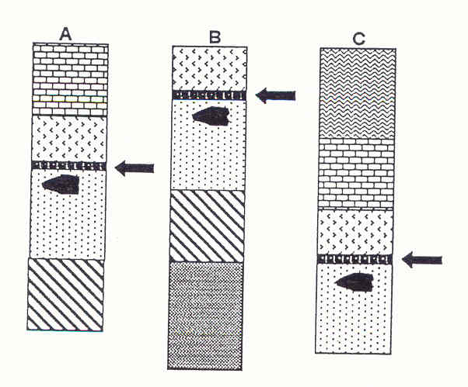

The three sets of layers from different archaeological dig sites shown above have suffered differing amount of surface erosion. A layer of volcanic ash (arrowed) has been dated to approximately
200 000 – 300 000 years ago. Crudely made stone tools are found in all sites in a discrete layer, immediately below the ash layer. Immediately above the volcanic ash is a layer with an unusual collection fossilised bones, from animals living on an ancient shoreline.

- What name is given this method of studying rock layers in archaeology?
Stratigraphy or “correlation of rock strata”

1 mark
- Which of the dig sites A, B, or C, contains the youngest layer?
C

1 mark
- How do you know this is the youngest?
Using the principle of superposition – the older layers of strata are covered by younger layers of rock
1 mark

- What name is given to such a group of fossils that is found in different parts of the world and that indicates a specific period of time

Index fossils

1 mark

e) Carefully constructed stone tools, ash from an ancient hearth (dated at 30,000 years old), and hominin bones found on the floor of a cave. The walls of the cave are decorated in mural art.

i. Which of these evidences of early life is a fossil? Explain why.

fossils are the physical remains or impressions left by an organism from the past (1)
Examples are: hominin bones (1)

ii. Which of these evidences of early life is an artefact? Explain why.

Aretfacts – evidence of human activity (1)
Example: ashes, art, stone tools (1)

4 marks

Question 25 (17 marks)
a) Describe THREE adaptations for tree life that are found in humans and in other primates, and how these adaptations are suited to arboreal life.

6 marks
(1 mark – adaptation – 1 mark how it is suitable)

* grasping limbs / fingerprints / fingerpads / nails
* needed for grasping / holding on to / climbing trees (branches)

* rotating forelimb / shoulder blade (scapula) on back of thorax / free wrist movement / well developed clavicle
* allows hanging from arms / arms support the weight of the body

* stereoscopic / binocular vision
* to judge distances

three different adaptations must be explained properly in relation to how they are specific to arboreal life.

b) A team of anthropologists discovered three intact fossilised jaws, each with a complete set of teeth. The size of the teeth was calculated so that comparisons could be made between the fossilised remains. Their results are tabulated below.

Cross-sectional areas of teeth (mm²)

Tooth | Hominin 1 | Hominin 2 | Hominin 3
First incisor | 79 | 78 | 80
Second incisor | 66 | 44 | 52
Canine | 98 | 91 | 86
First premolar | 101 | 111 | 185
Second premolar | 95 | 117 | 212
First molar | 150 | 173 | 269
Second molar | 147 | 213 | 361
Third Molar | 116 | 206 | 335

(i) Why is it that teeth are the most commonly found fossilised remains of hominins?

Teeth are easy to preserve (or preserve well)
Teeth do not decompose like soft tissue, (very tough)
Can become petrified
teeth are not eaten by predators

(Any 2)
2 marks

(ii) Additional evidence found by the anthropologists clearly indicated that hominin 1 was a hunter-gatherer who used fire and hominin 3 did not use fire. Comment on the likely diet of hominin 3. Explain which evidence led you to your conclusion.

Large molars and pre molars (1) → for grinding vegetation (1)
Must provide evidence and explanation
2 marks

(iii) Based on the above evidence (including information in part (ii)) which hominin, 1 or 3, would you expect to have a larger cranial capacity? Give ONE reason to support your answer.
Hominin 1 – larger cranial capacity (1)
Reason: hominin 1 may be a meat eater – this provided the ancestors with amino acids and energy to allow brains to increase in size. Reduced surface area of molars and premolars – less vegetation in diet – may eat meat – this would provide the amino acids that contribute to brain development (1)

Absence of amino acids and energy from meat prevented hominin 3’s brain from increasing in size

Need include information from part ii to get full marks:
hunter-gather lifestyle and ability to create and use fire suggests larger brain

2 marks

Read the extract below and answer the questions that follow.
We [compared] segment angles (trunk, thigh, lower-leg and foot) and joint angles (hip, knee, and ankle) for the hind limbs of bonobos walking bipedal (“bent-hip bent-knee walking,” …) and quadrupedally. Data were based on video recordings … of nine subjects in a lateral (side-on) view, walking at voluntary speed. The major differences between bipedal and quadrupedal walking are found in the trunk, thigh, and hip angles. During bipedal walking, the trunk is approximately 33– 41° more erect than during quadrupedal locomotion, although it is considerably more bent forward than in normal human locomotion. During bipedal walking, the hip has a smaller range of motion (by 12°) and is more extended (by 20 - 35°) than during quadrupedal walking. In general, angle profiles in bonobos are much more variable than in humans. Relationships of subsequent joint angles show that hip-knee coordination is similar for bipedal and quadrupedal walking, and resembles the human pattern.

Article Adapted from: “Segment and Joint Angles of Hind Limb During Bipedal and Quadrupedal Walking of the Bonobo (Pan paniscus)”. The American Journal Of Physical Anthropology 119:37–51 (2002)
Kristiaan D’Aout, Peter Aerts,Dirk De Clercq,Koen De Meester,and Linda Van Elsacker

a) What were the researchers investigating?

Researchers are comparing the angles of a bonobo’s body is at when walking bipedally to quadrupedally

1 mark

b) Although researchers often look for similarities between species, this study found both similarities and differences. What were TWO of the biggest differences?

- The trunk of the bonobo is 33-41 more erect when bipedal
- The hip has a smaller range of movement when bipedal
- Hip is more extended when bipedal
(Any 2)

2 mark

c) With data based on an experiment, what are TWO variables would the researchers have controlled?

- Age of bonobo
- health of the bonobo
- height of bonobo
- speed of pace when walking
(any 2 reasonable variables)

2 marks

Question 26 (16 Marks)

a) Match the correct term to the description by writing the letter on the line provided.

TERM

A. Co-dominant

B. Multiple allele

C. Allele

D. Polygenic inheritance

E. Gene expression

F. Intron

G. Exon

H. Epigenetic inheritance

I. Gene pool

J. Allele frequency
DESCRIPTION

__D__ Many pairs of genes influence a characteristic.

___H__ Traits that have been inherited, may or may not be expressed.

__F___ “Junk DNA” that does not code for traits.

__A___ Both alleles for a trait are expressed.

___B__ There are more than 2 different alleles for a trait.

___I__ The sum of all alleles in a population.

6 marks

b) Complete the following table summarising these differences between DNA and RNA.

DNA or RNA ? (circle) | DNA or RNA ? (circle) (one mark only this row)
Single-stranded | Double-stranded (1)
Base pairs: C-G, A-U (1) | Base pairs: C-G, A-T
(Cytosine – Guanine (1) | (Cytosine – Guanine
Adenine – uracil) (1) | Adenine – Thymine)
Ribose sugar group | deoxyribose sugar group (1)
6 marks
c) PCR is an important technique in which a section of DNA can be recognised and then amplified in a test tube.
(i) What does the acronym PCR stand for?

_____________Polymerase chain reaction_______________________
1 mark

(ii) The key to successful PCR is an appropriate set of primers. What are primers and what do they do?
- short, chemically synthesised DNA molecules
- they are used to mark two ends of a target sequence of DNA that the experimenter wishes to amplify in a test tube
- they are complementary to specific sequences of DNA at either end of the target sequence

3 marks

Question 27 (6 marks)

- What is meant by the term MUTATION?

A mutation is the change in a nucleotide sequence or the alteration of DNA that affects a portion of a chromosome

1 mark
- Why are mutations an essential component of natural selection?

Necessary to bring about variation
1 mark

- Apart from mutations name two other factors that are necessary before natural selection can take place.

Variation must exist

Selective pressures must exist

Mutation must provide some advantage (adaptation) to suit the environment

Competition for resources

(any two)

2 marks
Carefully read the information in the box below.
In Nepal, the many Himalayan valleys have been an inhabited region for thousands of years. The valleys are steep sided and many isolated villages can be found at their peaks. These villages consist of 200 – 300 people. Despite the fact that they live in identical climatic and environmental conditions, there is a great deal of variation between the villages in the gene frequency of blood groups.

Scientists have rejected the idea that natural selection has accounted for these differences and believe genetic drift to be the more likely reason.

- From the information provided, identify two reasons why scientists may believe that genetic drift has caused the difference in gene frequencies.

Geographical isolation separated the population – this prevent gene flow (1)

Small population size – reduces the size of the gene pool, restricts variation in mates (1)

(2 marks)
Question 28 8 marks)

Read the passage below on genetic engineering and insert the most correct word.

Viruses that infect bacterial cells are called bacteriophage (1). A key breakthrough that lead to recombinant DNA technology was the discovery that certain enzymes in bacteria are able to restrict the duplication of infecting viruses, by cutting up the viral DNA. Scientists discovered that this enzyme always cuts the DNA at a point where there is a specific sequence of bases. This is known as a recognition (1) site and the enzyme that cuts the DNA is a called a restriction (1) enzyme, because it restricts the duplication of bacteriophages. Some enzymes produce a straight cut at the sequence, while others produce a staggered cut. A straight cut is when the enzyme makes a clean break across the two strands of DNA to produce a blunt (1) (accepted “straight”) end. In this case both strands terminate in a base pair. On the other hand, some enzymes produce a staggered cut resulting in fragments with a sticky end (1) (*accept “staggered cut). This is a stretch of unpaired nucleotides in the DNA molecule that overhang at the break in the strands. They also have the ability to combine with sections of DNA that have a complementary ending, are very useful in recombinant DNA technology. A single-stranded overhang from one fragment can be paired with any other fragment of DNA that a different organism.
The enzyme DNA-ligase (1) could also be called a “DNA joining enzyme”. The process of “gluing” two ends together is called ligation (1).
Once a gene of interest has been isolated it can then be inserted into a vector to be cloned. The target will be circular, double-stranded units of cytoplasmic DNA called plasmids. (1) Once here the gene is duplicated and can be used in other applications.
8 marks
Question 29 (10 marks)

Genomic imprinting refers to a mechanism whereby only one of the two parental alleles is normally expressed while the other parental allele is not transcribed. The epigenetic marks associated with imprinted genes have recently been examined, and it is clear that DNA methylation, histone acetylation, and histone methylation influence the expression of particular alleles.
One of the most intensively studied imprinted genes is the gene that encodes the IGF-II receptor/mannose-6-phosphate receptor (IGF2R). The expression of this gene has been linked to suppressing tumors.

Adapted from: The Histone Code Regulating Expression of the Imprinted Mouse Igf2r Gene
Yang Y, Li T, Vu T, Ulaner A, Hu J, and Hoffman, A.
Endocrinology 144(12), 2003

A new drug has is being trialed to “reveal” the IGF-II gene to be transcribed, causing the gene to be fully expressed. In this experiment 10 mice with cancer and 10 without cancer are being compared. If the drug works the IGF-II gene will be expressed in the cells and tumor size will not increase.

a) State a suitable hypothesis

Administering of this drug will prevent tumors from growing. (or increasing)

(must link the drug with tumors)

2 marks

b) What is the independent variable in this experiment?

Presence of drug

1 mark

c) What is the dependent variable?

Tumor growth/size

1 mark

d) Is there a control group? Why do you think there is/isn’t?

No – there isn’t - there should be a group of mice with cancer that are not being given the drug. The 10 mice without cancer do not allow the size of the tumor to be compared overtime. The tumors may change size regardless of the drug. A control group of 10 mice with cancer who are not given the drug will show this.

1 mark

e) Why do researchers have a control group?

A control group allows for comparisons, to allow a change to be visible

1 mark

f) What are 2 variables that should be controlled?

Diet
Age
Metabolism
Amount to drug given
Same cage conditions for each mouse
(anything viable)

2 marks

g) What is one ethical consideration that must be made?

Humane treatment of the mice

1 mark

h) What would make the results more reliable?

Larger sample size

1 mark

Section Three: Extended answer 30% (60 Marks)

This section contains three (3) questions. You must answer two (2) questions. Write your answers in the space provided.

Minus 1 mark if they give answers as a table – and a table is not specified in the question

Question 30 (30 marks)

a) Compare the 3 methods (CARRIER MEDIATED TRANSPORT, DIFFUSION and VESICULAR TRANSPORT) of transporting substances into and out of the cell.
Give an example of substances that might use these methods.
Carrier Mediated Transport: cell membrane proteins bind to cell to move molecules across the membrane (1)
Once carrier molecules have all been used the process has reached its maximum speed (potential) to move substances (1)
Uses channel proteins (1)
Is regulated by hormones (1)
Two types: facilitated diffusion (1)
& active transport (1)
Facilitated Diffusion: passive – no energy require (1)
– with the concentration gradient (or from high to low concentration) (1)
eg: glucose, amino acids (1)
Active transport – movement against the concentration gradient (low to high)(1)
- requires energy (1)
eg: glucose, amino acids, certain ions (1)

Diffusion: movement from high to low concentration (1)
passive – no energy required (1)
eg. O₂ , fatty acids, H₂O, steroids, Na⁺, K⁺, lipid soluble (1)
moves across the via phospholipid bilayer (1)
channel proteins allow ions to diffuse (1)
water moves via osmosis (1)

Vesicular Transport: movement of substances in sac-like vesicles (1)
- vesicles are a part of the cell membrane (1)
molecules are engulfed and brought into the cell (1)
- two types of entry to the cell (endocytosis) (1)
requires energy (active) (1)
entry of liquids: pinocytosis (1)
eg: cholesterol, Fe²⁺ (1)
entry of solids: phagocytosis (1)
eg: cell debris, microbes (1)
expulsion of a substance from cell is exocytosis (1)
during which the vesicle membrane fuses with the cell membrane (1)
eg: mucus, digestive juices (1)

(any 20 points)

(20 marks)

b) Discuss the relationship between the change in diet and the change in skull, jaw and ultimately brain size during hominin evolution.
10 marks
ape and early hominin diet was largely vegetarian (1)
robust mandibles (1) and large grinding molars were needed to process tough vegetation (1)
climate change caused forests to turn to glasslands (1)
this caused apes/early hominins to look for food from the ground (1)
hominins evolved to eat meat (1)
brain size increased (1)
eating meat increases supply of protein / fat / energy making larger brain growth possible (1)
cranium increased to accommodate a larger brain (1)
decrease in size of teeth, (1) and mandible and prognathism (1) suits softer foods (1)
jaw becomes more parabolic (1)

+ any other good points
Question 31 (30 marks)

Explain and discuss the adaptations possessed by Homo sapiens that allow them an upright stance and the ability to walk bipedally and compare these adaptations to those possessed by pongids such as gorillas and chimpanzees. Use the TABLE in your Answer Booklet to construct your answer.
 | Pongids | Homo sapiens
Foramen magnum | - placed towards the back of the skull. (1)  - keeps the weight of the skull in front of the body (1) | - centrally placed at the base of the skull. (1)  - keeps the weight of the skull inline with (or over) the body (1)  - maintains a centre of gravity inline with the body (1)  (MAX OF 4)
Carrying angle | - a smaller carrying angle (1) the angle made by the femur at the knee (1)  - the femur is reasonably vertical towards the knees (1)  - ensures that weight is distributed outwards (1)  - sway from side to side so that the body weight is over each leg/whole body rotates (1) | - a larger carrying angle (1) the angle made by the femur at the knee (1)  - the femurs tend to converge towards the knees (1)  - ensures that weight distribution remains close to the central axis of the body when walking (1)  (MAX OF 6)
Pelvis | - Long (1) and narrow/ (1) | - broad (1) and short (1) pelvis  - bowl shaped (1)  - iliac flaring (1)  - supports the abdominal organs (1)  - broadness allows for greater muscle attachment to move lower limbs (1)  (MAX OF 6)
Feet | - Single longitudinal arch (1)  - Prehensibility (1) | - two arches longitudinal (1) and transverse (1)  - lack of prehensibility (1)  - big toe is aligned with the other toes (1) allowing  - big toe allows propulsion (1)  - enables striding gait (1)  - large calcaneous (1)  (MAX OF 5)
Prognathism | - Prognathic jaw (1)  - Weighty jaw puts centre of gravity in front of the central axis (1) | - Flat face/no prognathism (1)  - Keeps weight of the skull inline with the central axis (1)  (MAX OF 4)
Vertebral column | - C-shaped (1)  - Large neck muscles to hold the skull upright (1) | S – shaped (1)  Vertebral column directly under the centre of gravity of the skull (1)  * will also accept reduction in neck muscles to keep weight of the skull upright (1)  vertebrae increased in size from cervical → thoracic → lumbar bear an increasing amount of weight. (1)  (MAX OF 5)
(Any 30 points)
- any diagrams must be labeled
no dot points – full sentences only

Question 32 (formally 33) (30 marks)

Question 33 is comprised of THREEE (3) parts: A, B and C. You must answer all sections.

Part A
Malaria I a parasitic disease widespread in the tropics and transmitted by mosquitoes. Sickle-cell anaemia is a recessive gene disorder found in a relatively high proportion of people from tropical Africa. People carrying a single copy of the gene, (Aa), are generally healthy and less susceptible to malaria than people who do not carry the gene (AA). People who are homozygous for this gene (aa) are also less susceptible to malaria, but develop a form of anaemia that is almost always fatal.

Define what is meant by natural selection. Also describe how this trait has arisen and remained prevalent in this population.
10 marks

natural selection – organism has favourable traits to the environment (1)
- more likely chance of organism surviving to reproduce (1)
- this trait is passed on (1)
- non-favoured traits decrease (1)
- there is variation in the population (1)

variation comes about from mutation (1)
mutations are passed on (1)

being heterozygous is favourable /selected for (1)
a heterozygote is less susceptible to malaria (1)
a heterozygote is more likely to survive to reproduce (1)
a heterozygote is more likely to pass on resistance to malaria (1)
frequencies of those with a heterozygous genotype increase (1)

Question 32 (formally 33) (Cont.)

Part B
Evolution by natural selection is a commonly accepted theory for the appearance of diverse forms of life on earth. Discuss SIX (6) lines of evidence that suggests all vertebrates may have arisen from a common ancestor.
12 marks
must have 6 pieces of evidence
(no marks if they just give a name but don’t (attempt to) describe it)
(can give one mark if an example is given and but must be explained)

natural selection – organism has favourable traits to the environment (1)
- more likely chance of organism surviving to reproduce (1)
- this trait is passed on (1)
- non-favoured traits decrease (1)
- there is variation in the population (1)
- traits selected for by environmental pressures (1)

variation comes about from mutation (1)
mutations are passed on (1)

being heterozygous is favourable /selected for (1)
a heterozygote is less susceptible to malaria (1)
a heterozygote is more likely to survive to reproduce (1)
a heterozygote is more likely to pass on resistance to malaria (1)
frequencies of those with a heterozygous genotype increase (1)

Question 32 (formally 33) (Cont.)

Part B
Evolution by natural selection is a commonly accepted theory for the appearance of diverse forms of life on earth. Discuss SIX (6) lines of evidence that suggests all vertebrates may have arisen from a common ancestor.
12 marks
must have 6 pieces of evidence
(no marks if they just give a name but don’t (attempt to) describe it)
(can give one mark if an example is given and but must be explained)

Comparative embryology
- compares vertebrates during early stages of development
- tail, gill pouches and arches, limb buds, 2-chambered heart exist in many different species.
- Evidence that different species descended from common ancestor

(Comparative) DNA sequencing
- there will be similar sequences of nucleotide bases with common ancestors
- the less differences there are between the strands of DNA – the less phenotypic differences there will be.
- the closer a species is to a living species – the less different the sequences
- the non-coding (junk DNA or introns) strands are used for comparisons

(any two)

Protein sequencing
- proteins are made from amino acids
- comparison of the TYPE and SEQUENCE of amino acid chains between specimens
- ubiquitous proteins are those which appear in all species, that have the same function
- changes in the ubiquitous proteins can determine degree of similarity.
- The more changes (differences in the amino acid makeup) – the more distant the common ancestor.

(any two)

Mitochondrial DNA
- easy to obtain as each cell can have up to 1000 copies of mtDNA
- mtDNA is only obtained from the mother
- mtDNA mutates at a higher rate than DNA
- sequences of bases are used to determine the similarity between specimens
- common sequences to in species since past can indicate a common ancestor

(any two)
Question 32 (formally 33) (Cont.)

Homologous structures
- - Similar structures shared between species
- - indicate a common ancestor

Vestigial organs
- - Structures of reduced size or appear to have no function shared by different species
- - May have been utilized in a common ancestor.

Geographic Distribution
- Unique species found native isolated areas
- Evolved to adapt to their surroundings

Fossils
- Preserved remains of something that was living
- fossils can show a transition from a primitive species to a modern day species(a sequence of evolution)

evidence should be named and defined and elaborated on
Question 32 (formally 33) (Cont.)

Part C
The diagram below shows the front and side view of an Australopithecine.

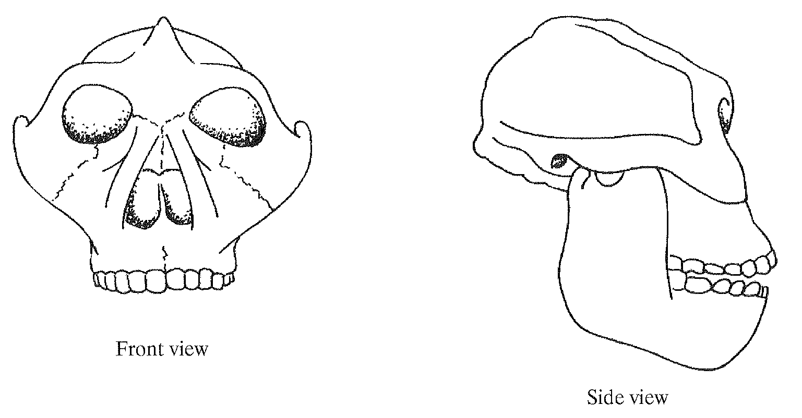

- What conclusions are likely to be drawn of this skull could give evidence about the posture, brain size and diet of this Australopithecine.

- small brain size (1)

- tough vegetative diet (no marks if they just said “for grinding”) (1)

- Posture close to being fully upright (1)

- What physical evidence would you be looking for on the skull?
- sloping forehead → smaller brain size (1)

- Posture close to being fully upright → foramen magnum close to being centrally located at the base of the skull (1)

- Large/robust mandible → tough vegetative diet (1)

- What method would you use to give an absolute time period of when this organism was alive?

- Potassium argon (1)

- Describe one assumption that must be made using this method of dating
(either) (1)
- the specimen is older than 200,000 years old
- radiometric dating relies on the random decay of isotopes.
8 marks

